INDIAN INSTITUTE OF TECHNOLOGY



**Evaluating the Impact of Vehicular and Industrial Activities on AQI: Insights from AQI Improvements During COVID-19 Lockdowns**

**Prepared by**

Avinash Choudhary (2106311)

Deepak Kumar (2103308)

Nitin Kumar Yadav (2104222)

November 12, 2024

**TABLE OF CONTENTS**

CHAPTER 1 : ABSTRACT

CHAPTER 2 : INTRODUCTION

CHAPTER 3 : LITERATURE REVIEW

CHAPTER 4 : METHODOLOGY

CHAPTER 5 : DATA ANALYSIS AND RESULTS

CHAPTER 6 : INTERPRETATION OF RESULTS

CHAPTER 7 : PROPOSING SOLUTIONS FOR EMISSION REDUCTION AND

ECONOMIC DEVELOPMENT

CHAPTER 8 : CONCLUSION

CHAPTER 9 : REFERENCES

**Abstract**

This report investigates the impact of vehicular and industrial activities on air quality, with a focus on the insights gained from significant AQI improvements observed during COVID-19 lockdowns in India. During these lockdowns, substantial reductions in air pollutant levels were recorded, providing a unique opportunity to assess the influence of decreased human activity on air quality. Utilizing data from major metropolitan cities such as Delhi, Mumbai, Kolkata, and Chennai, the study analyses AQI fluctuations across different lockdown phases to illustrate the effects of limited emissions from vehicles and industrial sources.

Key findings reveal marked decreases in pollutants like NO₂, SO₂, and particulate matter (PM2.5 and PM10), underscoring the substantial role of transportation and industrial emissions in urban air pollution. The study further evaluates the economic implications of reducing emissions through policies inspired by the successful initiatives of other nations, including vehicle emission standards and biofuel incentives. Through this comprehensive analysis, we propose actionable strategies for India to achieve sustainable improvements in air quality. This includes enhancing emission standards, promoting electric vehicles, and supporting the adoption of biofuels, particularly in rural areas where adaptation may require specific economic support. The report emphasizes that adopting these strategies, informed by international best practices, can yield significant health and economic benefits, aligning India’s environmental goals with improved public health outcomes and economic resilience.

**Introduction**

In recent decades, air pollution has emerged as one of the most critical environmental and public health concerns globally. According to the World Health Organization (WHO), 99% of the global population resides in areas where air pollution levels exceed safe guidelines, exposing billions to harmful airborne pollutants. This widespread exposure contributed to approximately 6.7 million deaths in 2019, highlighting the critical health burden of poor air quality globally (WHO, 2021). The World Bank estimates that the health damage caused by air pollution costs $8.1 trillion a year, equivalent to 6.1% of global GDP. The rapid pace of urbanization, industrialization, and population growth, particularly in developing nations, has intensified these air quality issues. India, as one of the fastest-growing economies, where both population and economic development increased rapidly in past decades, air pollution has reached a stage where many cities in India are among the most polluted cities in the world. In a recent World Air Quality 2018 report released by IQAir Group and Greenpeace (AirVisual, 2019), it was reported that fifteen of the top 20 most polluted cities in the world are located in India.

Air pollution in arises from a combination of anthropogenic and natural sources, driven largely by rapid urbanization, industrialization, and increased energy demands. Major contributors include road dust, vehicle emissions, industrial activities, waste burning, and construction dust. Vehicular and industrial pollution are major drivers of air quality issues in India. The surge in vehicles has led to increased emissions of nitrogen oxides, carbon monoxide, and other harmful pollutants, affecting urban air quality and public health. Similarly, industrial activities release sulphur dioxide, nitrogen oxides, and particulate matter, contributing to smog and environmental degradation. Together, these sources highlight the need for stricter emission controls and cleaner practices to address their impacts.

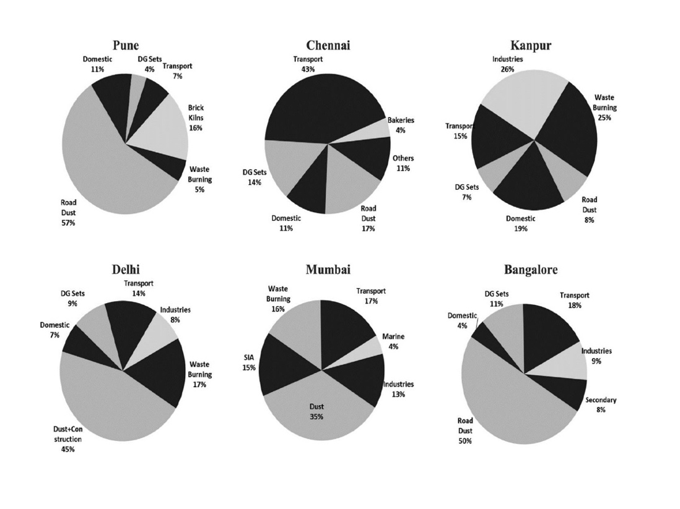

**Figure 1.** Average percent contributions of major sources to PM10 pollution. (Source: CPCB, 2010)

This report will evaluate the impact of vehicular and industrial activities on air quality, with a focus on the improvements in the Air Quality Index (AQI) observed during the COVID-19 lockdowns. By analysing AQI data from before, during, and after the lockdown, the report will explore how reductions in human activity led to significant improvements in air quality. The findings will be interpreted to propose strategies for achieving long-term improvements in air quality, including policies aimed at reducing emissions from vehicles and industries. Additionally, the report will assess the economic costs associated with implementing these policies, offering a comprehensive understanding of the financial implications of reducing air pollution sustainably.

**Literature review**

**Current State of Knowledge on Emission Contributions to AQI***:*

Vehicular and industrial emissions are recognized as major contributors to urban and regional air pollution, significantly impacting the Air Quality Index (AQI) in densely populated and industrialized areas globally. These two sectors emit a wide range of pollutants, which have profound consequences for human health, the environment, and economic stability. The relationship between emissions from these sectors and air quality is multifaceted, as both vehicles and industries release pollutants that directly contribute to the deterioration of air quality. This review provides an overview of the key pollutants released from vehicles and industries, the mechanisms by which they affect AQI, and their broader implications for air quality management.

1. **Vehicular Emissions and Their Impact on AQI**

Road transportation is a leading source of urban air pollution, with emissions from vehicles contributing significantly to the deterioration of AQI. The major pollutants emitted by vehicles include:

* **Nitrogen Oxides (NOx)**: NOx, primarily in the form of nitrogen dioxide (NO₂), is a major pollutant emitted by vehicles, especially diesel-powered engines. NOx contributes to the formation of ground-level ozone (O₃) and fine particulate matter (PM2.5) through photochemical reactions in the atmosphere. It is also a precursor to acid rain, which can further degrade air quality. In urban areas, vehicular emissions account for a significant portion (about 70%) of NOx emissions, significantly influencing AQI levels (World Bank, 2020).
* **Carbon Monoxide (CO)**: Emitted primarily by vehicles burning fossil fuels, carbon monoxide is a colourless, odourless gas that can be harmful at elevated concentrations. CO reduces the oxygen-carrying capacity of blood, causing serious health effects, especially in high-traffic areas with dense vehicular activity. It is responsible for the deterioration of air quality, particularly in urban settings.
* **Particulate Matter (PM)**: Vehicles, especially those with diesel engines, emit particulate matter (PM), including fine particles (PM2.5) and larger particles (PM10). These particles are harmful when inhaled as they can penetrate deep into the respiratory system, causing long-term health issues such as asthma, bronchitis, and cardiovascular diseases. PM2.5 particles, in particular, are a critical factor in AQI degradation due to their ability to remain suspended in the air for extended periods.
* **Hydrocarbons (HCs)**: Hydrocarbons, which include both volatile organic compounds (VOCs) and unburned fuel, are emitted during incomplete combustion processes in internal combustion engines. VOCs contribute to the formation of ground-level ozone and smog, which have detrimental effects on human health, visibility, and the environment.
* **Volatile Organic Compounds (VOCs)**: VOCs are a large group of organic chemicals emitted by vehicles. They play a major role in the formation of ground-level ozone and photochemical smog, particularly in the presence of sunlight. The effects of VOCs on AQI are particularly pronounced in warmer climates, where they promote the formation of harmful secondary pollutants.

1. **Industrial Emissions and Their Impact on AQI**

Industrial activities, including energy production, manufacturing, petrochemicals, and construction, contribute significantly to air pollution, with various pollutants emitted during different stages of industrial processes. The primary pollutants emitted by industries include:

* **Sulphur Dioxide (SO₂)**: A major pollutant emitted during the combustion of fossil fuels, particularly coal in power plants, sulphur dioxide contributes to the formation of sulfuric acid, which reacts with moisture in the atmosphere to form sulphate particulate matter (PM). These particles are a major cause of haze and poor air quality. SO₂ also contributes to acid rain, which can damage ecosystems, buildings, and water bodies.
* **Nitrogen Oxides (NOx)**: Similar to vehicular emissions, industries, particularly those involved in energy production, manufacturing, and petrochemicals, release large amounts of nitrogen oxides. NOx reacts with other compounds in the atmosphere to form ground-level ozone, particulate matter, and acid rain. These emissions are particularly high in regions with heavy industrial activity, directly correlating with poor AQI levels (Gurjar et al., 2020).
* **Volatile Organic Compounds (VOCs)**: Industrial activities, especially in the petrochemical sector, release significant quantities of VOCs, which contribute to the formation of ground-level ozone and photochemical smog. VOCs emitted from industrial sources are a precursor to the formation of secondary pollutants, exacerbating air quality issues, particularly in urban areas with high temperatures (Hagerman et al., 2019).
* **Ammonia (NH₃)**: Industrial processes, particularly those involving fertilizers and chemicals, release ammonia into the atmosphere. While ammonia is not directly harmful to human health at typical concentrations, it reacts with other airborne pollutants to form fine particulate matter, contributing to AQI degradation. Ammonia also plays a significant role in the formation of secondary particles in the atmosphere.
* **Particulate Matter (PM)**: Industries that involve energy production, construction, and manufacturing processes are major sources of primary particulate matter, including both PM2.5 and PM10. These particles, when emitted directly into the atmosphere, contribute to AQI degradation and pose significant health risks. Industrial facilities with high emissions of particulate matter, such as steel mills and power plants, are often located near urban centres, further intensifying air pollution.
* **Carbon Dioxide (CO₂)**: Although CO₂ does not directly impact AQI, it is a major greenhouse gas emitted by industries, especially in power generation and manufacturing. CO₂ contributes to global climate change, which in turn can indirectly affect air quality through changes in weather patterns, temperature inversions, and the increased frequency of extreme weather events.

In conclusion, vehicular and industrial emissions are major contributors to air pollution, with each sector releasing a wide array of pollutants that degrade air quality and impact the AQI. Vehicular emissions, including NOx, CO, PM, VOCs, and HCs, play a major role in air pollution, while industrial emissions of SO₂, NOx, VOCs, ammonia, and particulate matter further exacerbate air quality issues. The combined effects of these pollutants create a complex interplay that worsens AQI, leading to significant health and environmental consequences. Addressing the combined impacts of these sectors requires integrated efforts to reduce emissions at the source through cleaner technologies, stricter regulations, and sustainable urban planning.

Now, we will explore the effects of halting industrial and vehicular activities by examining a natural experiment: the large-scale lockdowns during the COVID-19 pandemic.

**Methodology**

This study utilizes data from the Continuous Ambient Air Quality Monitoring (CAAQM) network to examine air quality trends across several major cities in India—Delhi, Mumbai, Kolkata, Chennai, Jaipur, and Nagpur—during COVID-19 lockdown phases in 2020. The analysis is divided into three key phases to observe changes in air quality before and during the lockdown:

1. **Lockdown Phase 1 (March 25 – April 14, 2020)**: Nationwide strict lockdown with only essential services allowed.
2. **Lockdown Phase 2 (April 15 – May 3, 2020)**: Some relaxations in rural areas and industries, with restrictions based on COVID-19 zones (red, orange, green).
3. **Lockdown 3 (May 4 – May 17, 2020)**: More relaxations, including opening businesses in lower-risk zones, but public transport remained limited.

Air quality data was collected through openaq.org, which provides access to the official Central Pollution Control Board (CPCB) monitoring network. Pollutants analysed included PM10, PM2.5, SO2, and NO2, with averages computed for the entire day, while CO averages were calculated specifically for daytime hours.

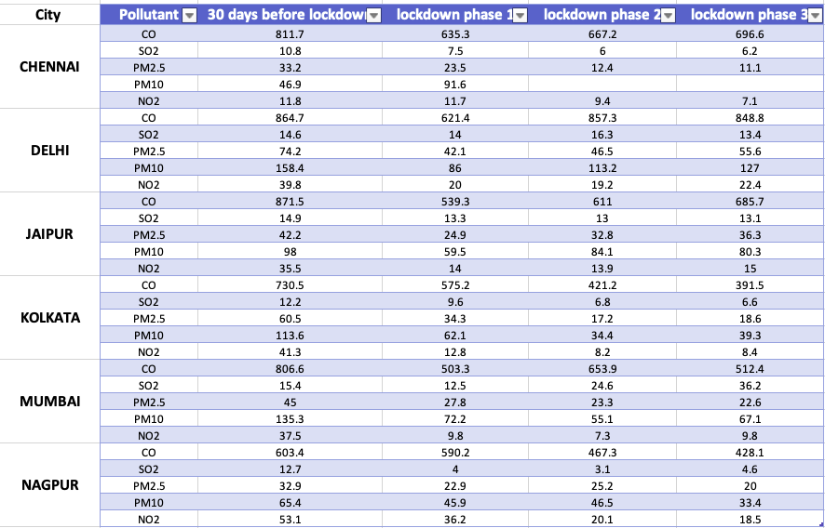

Fig 1 : AQI data before and during lockdown

**Data analysis and results**

**MUMBAI**

Mumbai, located on the coast, experiences distinct meteorological variations compared to other urban cities in India. While pre-lockdown levels of pollutants such as SO₂, PM₂.₅, NO₂, PM₁₀, and CO were relatively higher in Mumbai in 2020 compared to 2019, significant reductions were observed across various phases of the lockdown.

During Phase 1 of the lockdown (March 25th to April 14th, 2020), there was a notable reduction in the levels of pollutants. SO₂ levels decreased by 18.83%, NO₂ levels dropped by 73.87%, and PM₁₀ levels showed a 46.63% reduction. This decrease was primarily attributed to reduced vehicular emissions and industrial activities as restrictions were enforced. Contrary to initial observations, PM₂.₅ levels actually decreased by 38.22% during Phase 1, likely due to reduced industrial activities and lower traffic volume, despite the continued operation of certain sectors such as e-commerce and essential services. CO levels also saw a substantial decrease during this phase, dropping from 806.6 µg/m³ pre-lockdown to 503.3 µg/m³, representing a reduction of about 37.6%. This was a direct consequence of reduced vehicular traffic and industrial activities.

As Phase 2 (April 15th to May 3rd, 2020) began, the reduction in NO₂ and PM₁₀ levels continued to intensify, with NO₂ levels dropping by 80.53% and PM₁₀ levels by 59.28% compared to pre-lockdown values. PM₂.₅ levels, which had decreased in Phase 1, further reduced by 48.22% during Phase 2, reflecting the impact of the tightened lockdown restrictions and reduced industrial and vehicular activity. CO levels show some increment compare to phase-1, increasing from 503.3 µg/m³ in Phase 1 to 653.9 µg/m³ in Phase 2, indicating a slight increase compared to Phase 1 but still maintaining a 19% reduction compared to pre-lockdown levels. This slight rebound could be attributed to some relaxations in restrictions, leading to a minor increase in vehicular and industrial activities.

During Phase 3 (May 4th to May 17th, 2020), pollutant levels showed some changes compared to Phase 2. SO₂ levels increased by 47.0%, likely due to the reopening of industries. PM₂.₅ levels saw a slight increase of 3.0%, reflecting a minor rebound in activities, though still below pre-lockdown levels. PM₁₀ levels increased by 21.8%, possibly due to resumed construction and dust from reopened sectors. NO₂ levels rose by 34.2%, driven by the relaxation of restrictions on transport and industrial operations. Despite these increases, overall air quality remained better than pre-lockdown levels.

Overall, the lockdown in 2020 led to significant reductions in pollutants, especially during **Phase 1**, with notable declines in **SO₂**, **NO₂**, **PM₁₀**, **PM₂.₅**, and **CO** levels due to strict restrictions on traffic and industrial activities. In **Phase 2**, air quality continued to improve, with further reductions in **NO₂** and **PM₁₀**, though **CO** levels saw a slight increase as restrictions relaxed. By **Phase 3**, with more relaxations, pollutant levels rose, particularly **SO₂**, **PM₁₀**, and **NO₂**, but overall air quality remained better than pre-lockdown levels, highlighting the positive impact of reduced industrial and vehicular emissions.

**KOLKATA**

Kolkata, located near the Bay of Bengal, experienced a significant reduction in air pollutants during the lockdown. During Phase 1, Kolkata saw substantial reductions in most pollutants due to the strict lockdown measures. PM₂.₅ levels decreased by 43.24%, while PM₁₀ levels dropped by 45.38%, driven by reduced vehicular movement and construction activities. NO₂ levels experienced a sharp decrease of 68.95%, primarily due to reduced vehicular emissions. SO₂ levels also decreased by 21.31%.

During phase 2, the reductions in air pollutants continued. PM₂.₅ levels saw a further decrease of 71.47%, and PM₁₀ levels dropped by 69.74%, largely due to ongoing restrictions on construction and transport. NO₂ levels dropped by an additional 80.21%, reflecting the sustained reduction in vehicular emissions. SO₂ levels decreased by 44.26%, indicating a continued decline in industrial activity during this phase.

During Phase 3, pollutant levels showed some rebound as restrictions were eased. SO₂ levels increased by 2.94%, as industries resumed operations. PM₂.₅ levels increased by 7.3%, and PM₁₀ levels rose by 14.2%, likely due to the gradual reopening of construction and transport sectors. NO₂ levels rose by 9.1%, as more vehicles began operating with fewer restrictions. Despite these increases, air quality remained significantly better than pre-lockdown levels, demonstrating the lasting positive impact of the lockdown on pollution.

In conclusion, Kolkata experienced substantial reductions in PM₂.₅, PM₁₀, SO₂ and NO₂ during the lockdown,. The improvements in air quality, despite a mild rebound in Phase 3, reflected the positive effect of reduced vehicular and industrial activities.

**Nagpur**

Nagpur, an industrial hub, exhibited significant changes in air quality across the different phases of the 2020 lockdown, with notable reductions in key pollutants such as CO, SO₂, PM₂.₅, PM₁₀, and NO₂.

**CO Levels:** In Nagpur, CO levels were initially 603.4 µg/m³ before the lockdown, and during Phase 1, there was a small reduction to 590.2 µg/m³, a decrease of just 2.2%. However, during Phase 2, CO levels decreased further to 467.3 µg/m³, reflecting a 22.6% drop compared to pre-lockdown levels. In Phase 3, CO levels continued to decline, reaching 428.1 µg/m³, a 29% reduction from pre-lockdown levels. This trend indicates that CO emissions were significantly impacted by the reduced vehicular traffic and industrial activity, and the trend continued as the lockdown relaxed.

**SO₂ Levels:** SO₂ levels in Nagpur decreased sharply during Phase 1, from 12.7 µg/m³ to 4 µg/m³, reflecting a 68.5% reduction. This decline can be attributed to reduced industrial activities. The levels remained low in Phase 2 (3.1 µg/m³) but slightly increased to 4.6 µg/m³ in Phase 3, likely due to the gradual resumption of industrial activities as restrictions were relaxed.

**PM₂.₅ and PM₁₀ Levels:** PM₂.₅ levels in Nagpur dropped from 32.9 µg/m³ to 22.9 µg/m³ in Phase 1, a reduction of 30.5%. During Phase 2, PM₂.₅ levels slightly increased to 25.2 µg/m³ but remained below pre-lockdown levels. By Phase 3, PM₂.₅ levels fell to 20 µg/m³, indicating a sustained reduction in air pollution, although some recovery occurred as industries began reopening. PM₁₀ levels also followed a similar pattern, showing a significant drop of 29.9% in Phase 1, with further reductions in Phase 2 and Phase 3, highlighting a decrease in dust and vehicular emissions during the lockdown.

**NO₂ Levels:** NO₂ levels in Nagpur decreased by 31.9% in Phase 1, from 53.1 µg/m³ to 36.2 µg/m³. The reduction continued in Phase 2, with NO₂ levels falling to 20.1 µg/m³, a 62.2% drop compared to pre-lockdown levels. In Phase 3, NO₂ levels remained stable at 18.5 µg/m³, showing a minimal rise compared to Phase 2 but still reflecting the ongoing impact of reduced vehicular emissions.

In summary, Nagpur experienced considerable air quality improvements during the lockdown phases, with notable reductions in CO, SO₂, PM₂.₅, PM₁₀, and NO₂ levels. The progressive decline across phases demonstrates the impact of reduced vehicular and industrial activities, which were major contributors to air pollution in the city.

**Delhi**

Delhi, a densely populated metropolitan area with high vehicular and industrial emissions, experienced notable changes in pollutant levels during the lockdown phases of 2020. The variations in CO, SO₂, PM₂.₅, PM₁₀, and NO₂ levels reflect the impact of reduced activities and gradual reopening.

**CO Levels**: CO levels in Delhi showed a significant reduction, dropping by 28.1% in Phase 1, from 864.7 µg/m³ to 621.4 µg/m³. During Phase 2, CO levels rose slightly to 857.3 µg/m³, reflecting an increase in industrial activities and some resurgence in vehicular traffic. However, Phase 3 saw a slight decline to 848.8 µg/m³, indicating that while there was some recovery, CO levels remained lower than pre-lockdown values.

**SO₂ Levels:** SO₂ levels in Delhi showed a relatively small decrease during Phase 1, from 14.6 µg/m³ to 14 µg/m³, with a significant increase in Phase 2 to 16.3 µg/m³. This rise in SO₂ levels during Phase 2 can be attributed to the gradual resumption of industrial activities. In Phase 3, SO₂ levels dropped again to 13.4 µg/m³, reflecting a slight reduction in emissions as industries continued to adjust.

**PM₂.₅ and PM₁₀ Levels:** PM₂.₅ levels in Delhi saw a significant decrease of 43.2%, from 74.2 µg/m³ to 42.1 µg/m³ in Phase 1. However, the levels slightly increased in Phase 2 to 46.5 µg/m³ and further increased to 55.6 µg/m³ in Phase 3. This rise is likely due to increased industrial and vehicular activity. Similarly, PM₁₀ levels dropped by 45.7% in Phase 1 but showed a 31.7% rise in Phase 2 and a further increase in Phase 3, indicating the slow recovery of particulate matter in the air due to the relaxation of restrictions.

**NO₂ Levels:** NO₂ levels dropped by 49.9% in Phase 1, from 39.8 µg/m³ to 20 µg/m³. During Phase 2, NO₂ levels decreased slightly to 19.2 µg/m³, but in Phase 3, they slightly increased to 22.4 µg/m³, reflecting the effects of increased traffic and industrial activities.

In summary, Delhi’s air quality improved significantly during the initial lockdown phase, with CO, PM₂.₅, PM₁₀, and NO₂ levels showing substantial reductions. However, as industrial and vehicular activities resumed, pollutant levels gradually increased, indicating the critical role of human activities in Delhi's air pollution levels.

**Chennai**

Chennai, a coastal city with significant industrial and vehicular contributions to air pollution, experienced marked reductions in pollutant levels during the initial phases of the 2020 lockdown. The data on CO, SO₂, PM₂.₅, PM₁₀, and NO₂ levels show the impact of restricted activities and gradual easing.

**CO Levels:** CO levels in Chennai decreased significantly by 21.7%, from 811.7 µg/m³ to 635.3 µg/m³ in Phase 1. During Phase 2, CO levels increased slightly to 667.2 µg/m³ but remained lower than pre-lockdown levels. In Phase 3, CO levels rose to 696.6 µg/m³, indicating a gradual resurgence of vehicular and industrial activities.

**SO₂ Levels:** SO₂ levels in Chennai decreased from 10.8 µg/m³ to 7.5 µg/m³ in Phase 1, a reduction of 30.6%. During Phase 2, SO₂ levels further decreased to 6 µg/m³, but there was a slight increase to 6.2 µg/m³ in Phase 3 as some industrial activities resumed.

**PM₂.₅ and PM₁₀ Levels:** PM₂.₅ levels in Chennai dropped significantly by 29.3% during Phase 1, from 33.2 µg/m³ to 23.5 µg/m³. The levels continued to decrease during Phase 2 to 12.4 µg/m³, and slightly decreased further to 11.1 µg/m³ in Phase 3. PM₁₀ levels showed a significant increase in Phase 1, from 46.9 µg/m³ to 91.6 µg/m³, which is very strange behaviour and may be due to some running industries during lockdown. However, data for Phase 2 and 3 for PM₁₀ were not provided.

**NO₂ Levels:** NO₂ levels showed a minimal decrease during Phase 1, from 11.8 µg/m³ to 11.7 µg/m³, and dropped further during Phase 2 to 9.4 µg/m³. In Phase 3, NO₂ levels were 7.1 µg/m³, reflecting a continued reduction in vehicular and industrial emissions.

Overall, Chennai’s air quality improved considerably during the lockdown, especially with reductions in CO, SO₂, and PM₂.₅ levels. The ongoing decreases in NO₂ levels in later phases reflect the prolonged impact of lowered emissions from reduced urban activity.

**Jaipur**

Jaipur, known for its bustling tourism and industrial activities, saw noticeable air quality improvements during the lockdown phases of 2020. Analysing the variations in CO, SO₂, PM₂.₅, and PM₁₀ levels provides insight into the impact of activity reduction and gradual resumption.

**CO Levels**: CO levels in Jaipur were at 871.5 µg/m³ before the lockdown. During Phase 1, CO levels reduced significantly to 539.3 µg/m³, showing a 38.1% decrease. In Phase 2, CO levels rose slightly to 611 µg/m³, reflecting a partial return of activities. By Phase 3, CO increased further to 685.7 µg/m³, indicating a continued rise in vehicular and industrial emissions with the easing of restrictions.

**SO₂ Levels**: SO₂ levels in Jaipur saw a smaller reduction, decreasing from 14.9 µg/m³ before the lockdown to 13.3 µg/m³ in Phase 1 (a reduction of 10.7%). The levels then stabilized around 13 µg/m³ in Phase 2 and 13.1 µg/m³ in Phase 3, suggesting minimal change in SO₂ emissions despite varying lockdown restrictions.

**PM₂.₅ Levels**: PM₂.₅ levels in Jaipur dropped from 42.2 µg/m³ pre-lockdown to 24.9 µg/m³ in Phase 1, a 41% decrease. In Phase 2, PM₂.₅ levels rose to 32.8 µg/m³, reflecting increased particulate matter emissions as activities resumed. In Phase 3, levels further increased to 36.3 µg/m³, indicating a trend toward pre-lockdown pollution levels as restrictions eased.

**PM₁₀ Levels**: PM₁₀ levels in Jaipur also showed a substantial decrease from 98 µg/m³ before the lockdown to 59.5 µg/m³ in Phase 1, reflecting a 39.2% reduction. In Phase 2, levels increased to 84.1 µg/m³, and in Phase 3, PM₁₀ levels reached 80.3 µg/m³, indicating some recovery as restrictions relaxed but still lower than pre-lockdown levels.

**NO₂ Levels**: NO₂ levels in Jaipur showed a significant reduction during Phase 1, from 35.5 µg/m³ to 14 µg/m³, marking a 60.6% decrease. In Phase 2, levels remained low at 13.9 µg/m³ and showed a slight increase to 15 µg/m³ in Phase 3. This pattern suggests that NO₂, largely from vehicular emissions, was directly impacted by reduced traffic and resumed slightly as restrictions eased.

In summary, the data from Jaipur highlights the temporary improvements in air quality during the lockdown phases, particularly in CO and particulate matter levels. However, the gradual resurgence in Phase 3 points to the challenge of maintaining lower emission levels as industrial and vehicular activities return to normal.

**Interpretation of Results**

The data analysis revealed significant reductions in air pollutant levels across the six studied cities during the 2020 lockdown phases. These reductions were particularly evident in Phase 1, where vehicular traffic and industrial activities were heavily restricted, leading to a marked decrease in pollutants such as PM₂.₅, PM₁₀, NO₂, and CO. The most notable improvements were observed in cities like Kolkata and Mumbai, with NO₂ and PM₁₀ showing substantial declines. In Phase 2, as restrictions eased slightly, some pollutants such as CO and NO₂ showed minor increases, but overall air quality remained better than pre-lockdown levels. By Phase 3, with more relaxations, pollutants like SO₂, PM₁₀, and NO₂ began to rise, reflecting the gradual return of industrial and vehicular activities. Despite this, all cities, including Delhi, Nagpur, and Chennai, saw improvements in air quality compared to the pre-lockdown period, indicating the positive impact of reduced human activity on urban pollution levels. The sustained improvements in particulate matter and gaseous pollutants highlighted the role of reduced vehicular and industrial emissions in enhancing air quality. However the PM10 concentration in Chennai drastically increased which is very unlikely as compared to other cities in India.

**Proposing Solutions for Emission Reduction**

**and Economic Development**

**Identifying Successful Policies Globally**  
A recent global study of over 1,500 climate policies found that 63 policies significantly reduced emissions, with the most effective strategies combining subsidies, performance standards, and carbon pricing. For instance, the UK's success in banning coal plants was supported by financial incentives. Carbon pricing worked well in developed nations, while regulatory measures were more successful in developing countries. These insights could guide global emission reduction efforts.  
For more information, read here: [Smithsonian Article](https://www.smithsonianmag.com/smart-news/study-identifies-best-policies-for-reducing-carbon-emissions-180984980/)

**The Clean Air Act of the USA**  
The Clean Air Act has successfully reduced air pollution, notably from transportation. Since 1970, emissions from vehicles have dropped by over 98%, thanks to innovations like catalytic converters. The EPA’s policies continue to address climate change, especially targeting carbon emissions from transportation, which is now one of the largest sources of U.S. emissions.  
For more, visit: [EPA Accomplishments](https://www.epa.gov/transportation-air-pollution-and-climate-change/accomplishments-and-successes-reducing-air)

**California’s Low Carbon Fuel Standard (LCFS)**  
California’s LCFS promotes low-carbon fuels and zero-emission vehicles, achieving significant reductions in freight emissions. A comprehensive strategy of cleaner technologies, infrastructure upgrades, and financial incentives for electric trucks has made notable progress in reducing the U.S. freight sector’s environmental impact.  
Read more here: [WRI Article](https://www.wri.org/technical-perspectives/decarbonizing-freight-how-us-policies-and-investments-are-reducing-emissions)

**Promotion of Electric Vehicles (EVs)**  
Incentives for electric vehicles in regions like the U.S. and China are projected to significantly reduce emissions by 2035. China’s early adoption of EVs contributed substantially to global avoided emissions in 2023. The U.S. EPA's latest vehicle pollution standards aim to save emissions and improve public health.  
For more, visit: [EPA News Release](https://www.epa.gov/newsreleases/what-they-are-saying-strongest-ever-pollution-standards-cars-will-reduce-pollution)

**Adapting Global Policies to Rural India**  
India’s rural areas face unique challenges, such as reliance on older automobiles and diesel engines in agricultural equipment. Direct implementation of vehicle emissions rules may be difficult due to economic constraints. However, strategies like the Clean Air Act and California’s LCFS can be adapted to address local realities.

**Issues in Rural Areas**  
In rural areas, the use of diesel engines in farm equipment and older vehicles is a major source of pollution. Public health is also affected by dust from construction, industrial pollution, and crop stubble burning. These contribute to high AQI levels, especially in the winter months.

**Proposed Solutions for Rural Areas**

1. **Subsidies for Cleaner Equipment**: Offer incentives for the purchase of electric or hybrid farm machinery, similar to U.S. pollution control strategies.
2. **Awareness Campaigns**: Launch regional language campaigns to educate about the health risks of air pollution and the benefits of cleaner vehicles.
3. **Retrofit Hubs**: Establish local centres to install emission-reducing technologies like diesel particle filters on older vehicles.
4. **Promote Local Biofuels**: Incentivize biofuel production from agricultural waste, reducing reliance on diesel and lowering carbon intensity.
5. **EV Infrastructure**: Expand electric vehicle charging stations in rural areas, starting with smaller vehicles like electric two- and three-wheelers.
6. **Incentivize Clean Public Transport**: Subsidize electric or low-carbon fuel options for rural public transport, potentially creating local jobs.

**Addressing the Lack of Transparency in Industrial Emissions**  
Inconsistent emissions data hampers India's ability to regulate pollution effectively. To address this, the government should mandate real-time emissions reporting, use IoT sensors, and satellite monitoring for accuracy. Public access to this data will encourage compliance, while penalties for non-reporting and incentives for low-emission practices will further promote transparency. Community-driven monitoring initiatives can enhance accountability.

**Use of Air Purification Technology**  
Large-scale air purifiers, such as smog towers, can help reduce localized pollution in heavily affected areas.

**Enhanced Public Transport Systems**  
Develop clean and efficient public transportation systems to reduce reliance on private vehicles, thus lowering emissions.

**Crop Stubble Management**  
Implement low-cost stubble management techniques like crop residue decomposition and using stubble in biofuel production to reduce the environmental impact of crop burning.

**Economic Aspects of the Proposed Policies**

1. **Healthcare Savings**: Reducing air pollution will significantly lower healthcare costs related to respiratory and cardiovascular diseases.
2. **Job Creation**: Establishing retrofit centres and promoting green technologies will create local employment opportunities.
3. **Agricultural Productivity**: Cleaner and more efficient farm equipment will reduce downtime and boost agricultural productivity, benefiting rural economies.

**Economic Benefits of Biofuel Production**  
Encouraging biofuel production from agricultural waste will reduce dependence on imported fuels, stabilize fuel prices, and create jobs in rural areas.

**Long-Term Fuel Savings with Electric Vehicles**  
Though the initial cost of EV infrastructure and vehicles is high, long-term fuel savings will reduce transportation costs for rural households and businesses.

**Public Health and Economic Benefits**  
Reducing emissions through cleaner transportation and fuels will lead to lower healthcare costs and increased worker productivity, promoting a positive economic cycle in rural India.

**Final Thoughts**  
Addressing the pollution crisis in India requires a combination of stringent policies, cleaner technologies, and infrastructure development. By adapting successful global strategies like the Clean Air Act and California’s LCFS to India's rural realities, significant reductions in emissions can be achieved. Additionally, the economic benefits—such as job creation, reduced healthcare costs, and increased agricultural productivity—further justify the investment in these policies. Ultimately, these measures will help foster a more sustainable and healthier environment for both rural and urban India.

for Emission Reduction and Economic Development

**Conclusion**

The COVID-19 lockdown served as a natural experiment, highlighting the potential for significant improvements in air quality when vehicular and industrial emissions are drastically reduced. Although these improvements were temporary, they demonstrate the effectiveness of reducing emissions at their source—such as through better dust control, cleaner transport, and greener industrial practices. To achieve long-term, sustainable improvements in air quality, lessons learned from the pandemic must be integrated into business-as-usual scenarios. This includes implementing strategies like optimizing traffic management, encouraging public transportation, and adopting green technologies in industries.

This analysis forms a solid foundation for policy recommendations aimed at reducing pollution from key sources. Transitioning to cleaner fuels, incentivizing electric vehicles, and investing in green infrastructure are all essential steps in improving urban air quality and public health in a sustainable way. Balancing industrial development and urbanization with the carrying capacity of cities is also crucial in maintaining long-term air quality improvements, ensuring that socio-economic growth is aligned with environmental sustainability.

**References**

* **Urban emission info** : <https://urbanemissions.info/blog-pieces/india-airquality-covid19/>
* **EPA (2018) :** <https://www.epa.gov/air-pollution-transportation>
* **World Bank (2020 :** <https://www.worldbank.org/en/topic/environment/brief/air-pollution>
* **Bates, J.T., et al. (2019) :** <https://ehp.niehs.nih.gov/doi/full/10.1289/EHP4223>
* **IEA (2019) :** <https://www.iea.org/reports/world-energy-outlook-2019>
* **European Environment Agency (2021) :** <https://www.eea.europa.eu/themes/air/industrial-pollution>
* **Gurjar, B.R., et al. (2020) :** https://doi.org/10.1016/j.atmosenv.2020.117125
* **Hagerman, T.L., et al. (2019) :**  https://doi.org/10.1016/j.jes.2019.02.010
* **WHO (2018) :** <https://www.who.int/airpollution>
* **Chen, Y., & Wang, L. (2020) :** <https://doi.org/10.1021/acs.est.0c00598>
* **Dockery, D.W., et al. (2018) :** https://doi.org/10.1146/annurev-publhealth-040617-013623
* **Landrigan, P.J., et al. (2018) :** https://doi.org/10.1016/S0140-6736(17)32345-0
* **Ashmore, M.R. (2019) :** <https://doi.org/10.1098/rstb.2013.0580>